

**MIDDLE EAST TECHNICAL UNIVERSITY**

**Electrical & Electronics Engineering Department**

**EE494 - Engineering Design II**

***“Cısss!”***

***Test Sheet***

**Company Name:** Lambda

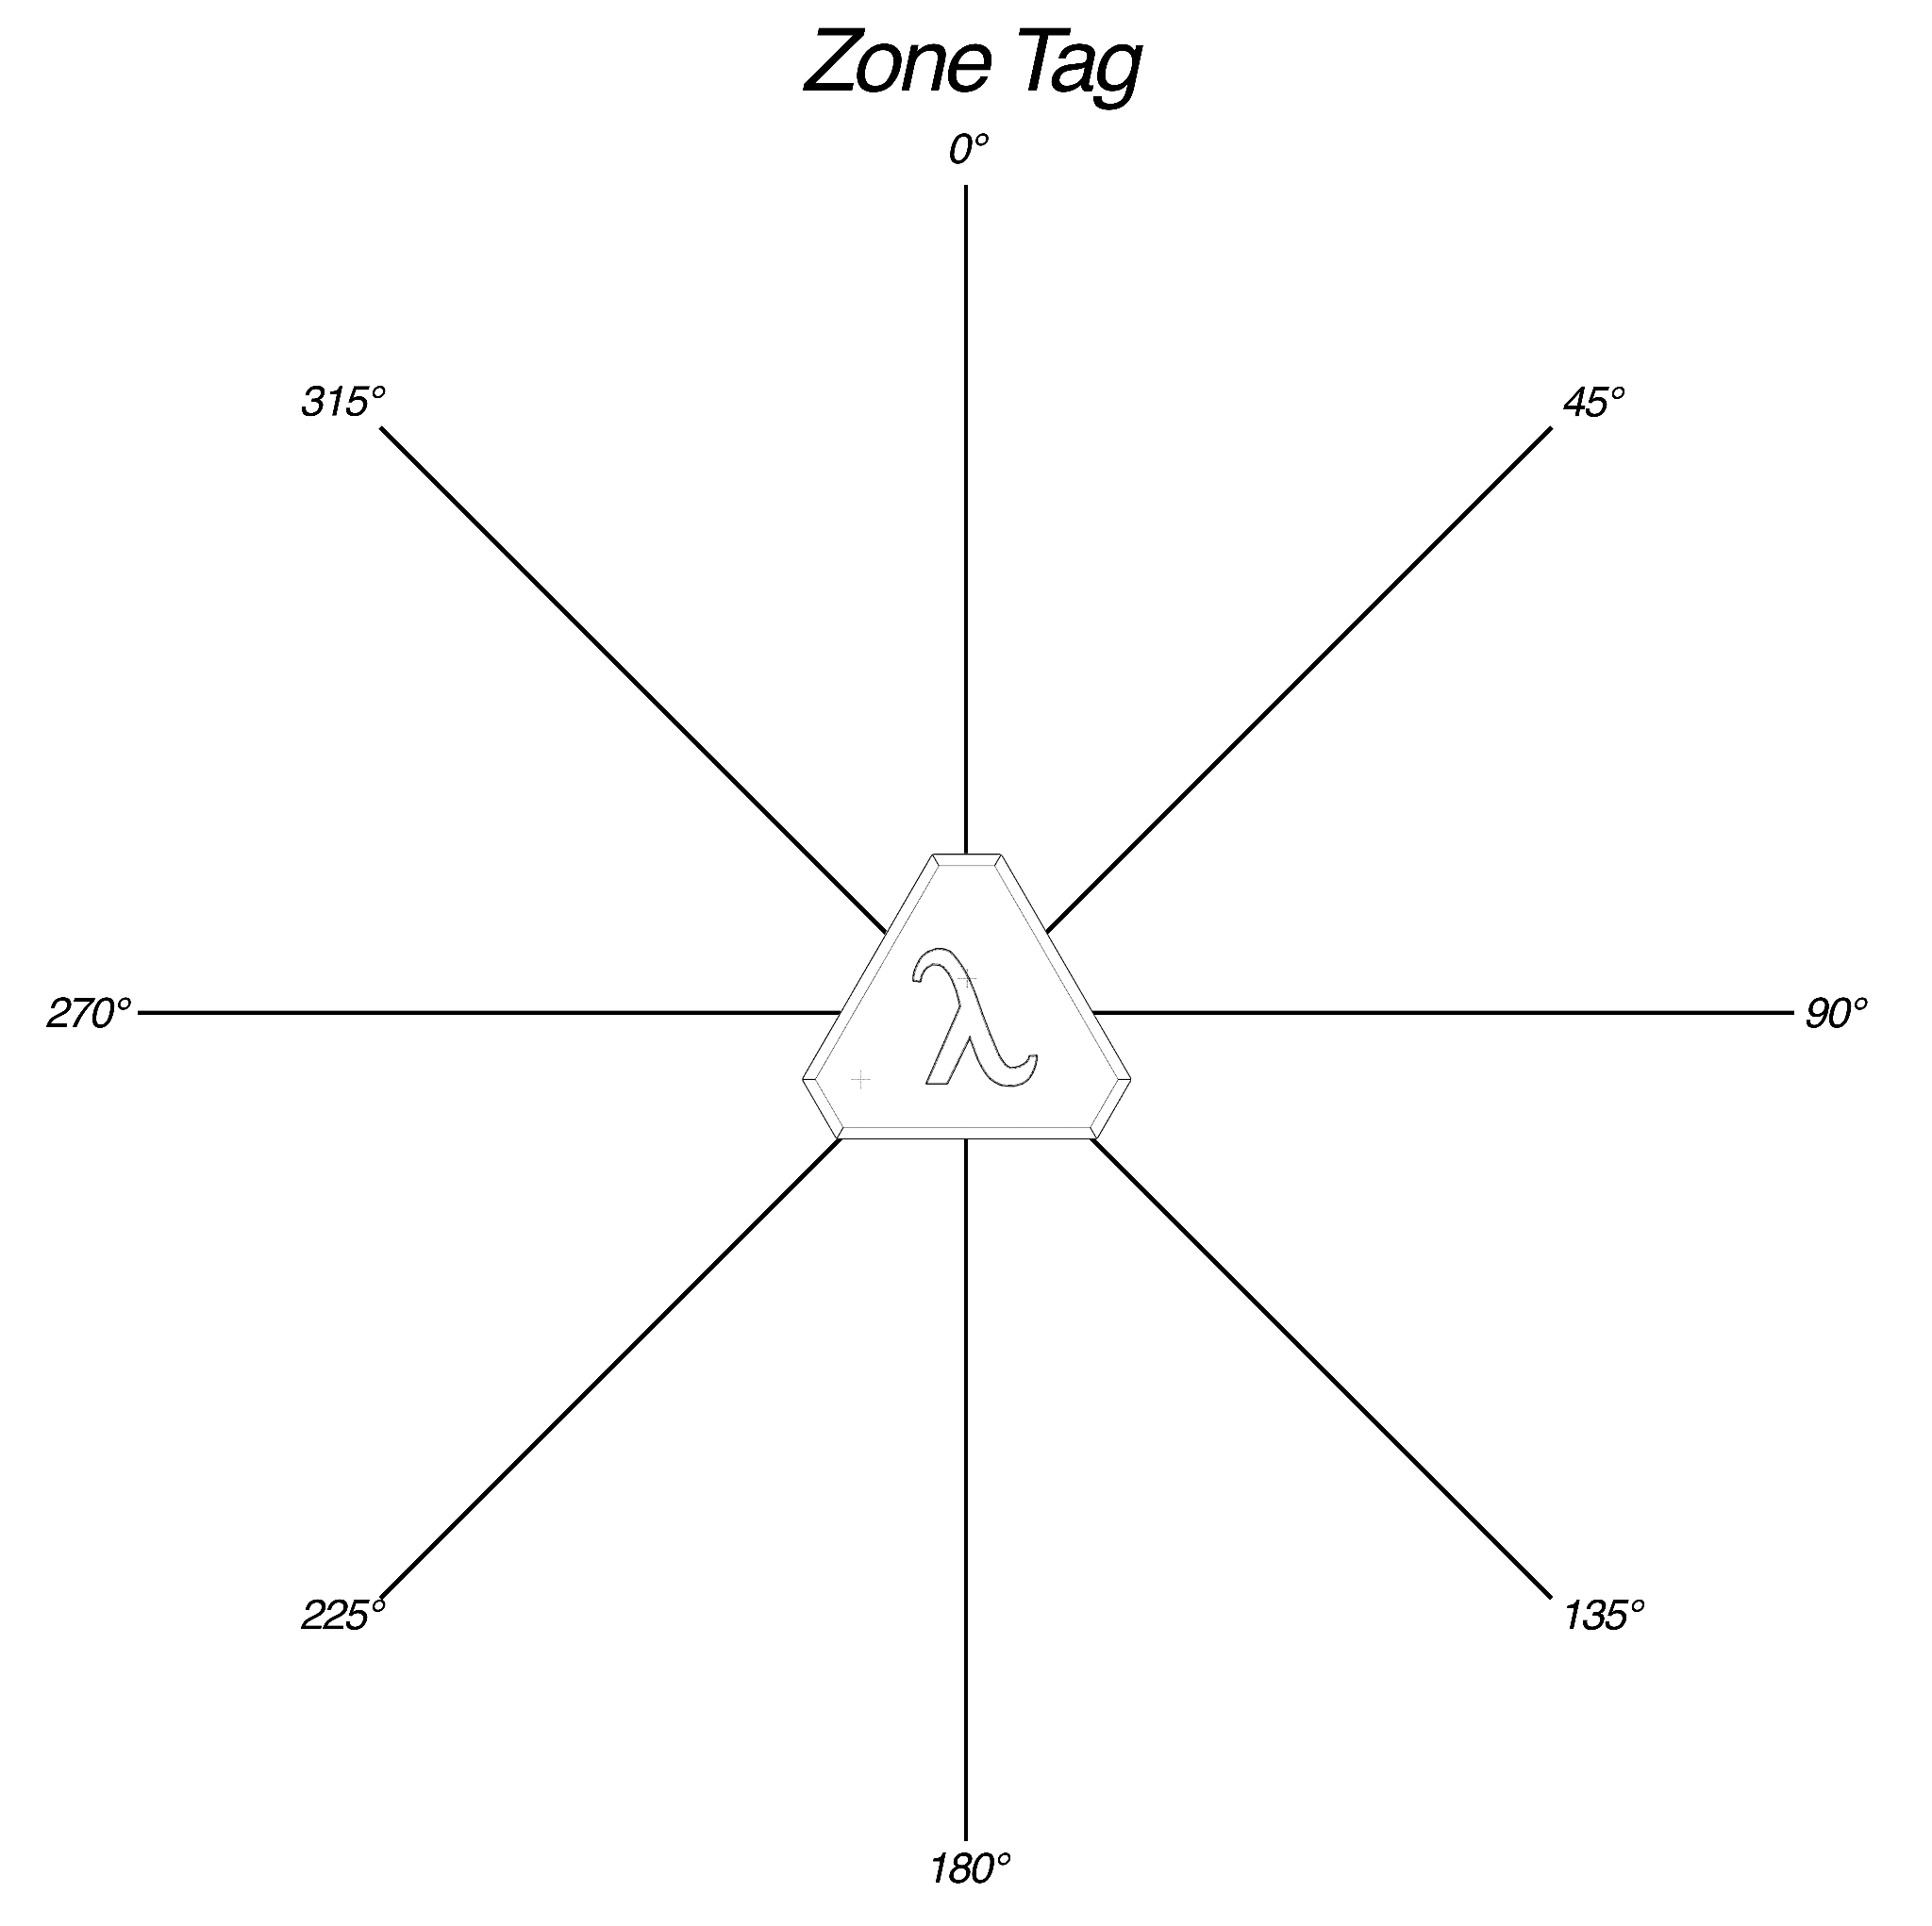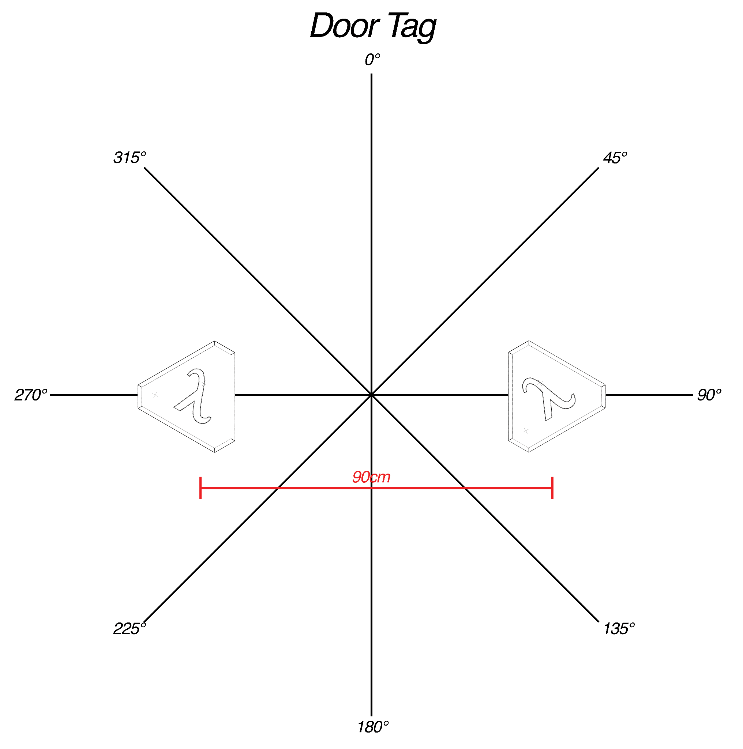

**Starting Date of the Project:** 18.10.2021

**Completion Date of the Project:** 15.06.2022

**The Project Duration:** ~ 8 Months

**Members of Company:**

1. Alper Saraç - 2305258
2. Necdet Can Sönmez - 2305357
3. Mustafa Barış Emektar - 2304533
4. Berk Erhan Yüksel - 2305829
5. Furkan İtkü - 2304822

**Design Coordinator:**

* Associate Professor Dr. Elif Vural

| **Distance Estimation Testing Scenarios** | | | | | | | | |
| --- | --- | --- | --- | --- | --- | --- | --- | --- |
|  | **Test Case** | **Tag-Master Facing Direction** | **Measurements** | | | | | |
| **Far State Entry (80cm)**  **Distance (cm) / Error (%)** | | **Medium State Entry(60cm)**  **Distance (cm) / Error (%)** | | **Close State Entry(40cm)**  **Distance (cm) / Error (%)** | |
| **Zone Tag** | Walking towards & away | Facing towards | 108 | 35,0 | 82 | 36,6 | 52 | 30,0 |
| Walking towards & away | Facing 45° | 84 | 5,0 | 64 | 6,6 | 37 | -7,5 |
| Walking towards & away | Facing 90° | 63 | -21,2 | 48 | -20,0 | 30 | -25 |
| Walking towards & away | Facing 135° | 35 | -56,2 | * | * | * | * |
| Walking towards & away | Facing 180° | 78 | -2,5 | 63 | 5,0 | 42 | 5,0 |
| Walking towards & away | Facing 225° | 74 | -7,5 | 67 | 11,6 | 46 | 15,0 |
| Walking towards & away | Facing 270° | 58 | -27,5 | 28 | -38,3 | * | * |
| Walking towards & away | Facing 315° | 74 | -7,5 | 53 | -11,6 | 37 | -7,5 |

* *The* ***height difference*** *between master and tag is* ***30-40 cm*** *(an average pet height) in all test cases above.*
* *The distances are* ***direct distances****, NOT projectile distances.*

| **Distance Estimation Testing Scenarios** | | | | | | | | | | | | |
| --- | --- | --- | --- | --- | --- | --- | --- | --- | --- | --- | --- | --- |
|  | **Tag Direction Angle** | **Test Case** | **Tag-Master Facing Direction** | **Measurements** | | | | | | | | |
| **Far State Entry (70cm)**  **Distance (cm) / Normalized (cm) / Error (%)** | | | **Medium State Entry (50cm)**  **Distance (cm) / Normalized (cm) / Error (%)** | | | **Close State Entry (40cm)**  **Distance (cm) / Normalized (cm) / Error (%)** | | |
| **Door Tag** | **±60°** | W T&A | Towards | 105 | 105 | 50,0 | 64 | 64 | 28,0 | 48 | 48 | 20,0 |
| W T&A | Facing 45° | 93 | 69 | -1,5 | 80 | 57 | 15,4 | 58 | 41 | 3,0 |
| W T&A | Facing -45° | 92 | 68 | -2,7 | 75 | 53 | 7,2 | 66 | 46 | 16,7 |
| W T&A | Facing ±90° | * | * | * | * | * | * | * | * | * |
| **0°**  **(Parallel)** | W T&A | Towards | 74 | 74 | 5,7 | 54 | 54 | 8,0 | * | * | * |
| W T&A | Facing 45° | 110 | 84 | 20,6 | 90 | 66 | 32,6 | 70 | 49 | 24,3 |
| W T&A | Facing -45° | 112 | 86 | 23,2 | 80 | 57 | 15,4 | 66 | 46 | 16,8 |
| W T&A | Facing ±90° | * | * | * | * | * | * | * | * | * |

* *W T&A = Walking towards & away*
* *A result of “*” implies that the state was not observed.*
* *The* ***height difference*** *between master and tag is* ***30-40 cm*** *(an average pet height) in all test cases above.*
* *The distances are* ***direct distances****, NOT projectile distances.*
* ***Normalized Distance*** *means “****distance to closest tag****”. For the door tag cases, the distance to the center of the doorway was measured for practical purposes. In the error calculation, the distance to the closest tag was used.*

| **Miscellaneous Testing Scenarios** | | |  | **Obstruction Testing Scenarios** | | |
| --- | --- | --- | --- | --- | --- | --- |
|  | **Test Case** | **Tag - Master**  **Facing Direction** |  |  | **Obstruction Type** | **Pass/Fail** |
|
| **Tag Classification** | During start-up/operation, the tags will be classified as either zone or door tags | Facing towards |  | **Zone Tag** | Metal | ✖ |
| **Tag Switch** | After the master classifies door tags, the tag positions will be shuffled, and the master will be reset. | Alternating direction |  | Wood | **✓** |
| **Zone Tag** | Approaching in a straight trajectory, slowly | Facing towards |  | Human Hand | **✓** |
| Approaching in a straight trajectory, fast | Facing towards |  | Human Body | ✖ |
| Approaching in spiral trajectory | Alternating direction |  | Foam | **✓** |
| **Door Tag** | Approaching in a straight trajectory, slowly | Facing towards |  |  |  |  |
| Approaching in a straight trajectory, fast | Facing towards |  |  |  |  |
| Approaching in spiral trajectory | Alternating direction |  |  |  |  |